PANDEMIC EFFECTS ON SENTIMENT ANALYSED FROM TWEETS AND NEWS PAPER REPORTS

Project Report Submitted in Partial Fulfilment of the
Requirements for the degree of
Master of Computer Application
Of
Jadavpur University
September 2020

By
Supriyo Das
Master of Computer Application – III
Class Roll Number: 001710503025
Registration Number: 140814 of 2017-2018

Under the guidance of
Dr. CHITRITA CHAUDHURI
Associate Professor

Department of Computer Science and Engineering
Faculty of Engineering and Technology
Jadavpur University
Kolkata – 700032, India
September 2020
Department of Computer Science and Engineering
Faculty of Engineering and Technology
Jadavpur University

TO WHOM IT MAY CONCERN

I hereby forward the project report entitled “Pandemic Effects on Sentiment Analysed from Tweets and News Paper Reports” prepared by Supriyo Das under my supervision to be accepted in partial fulfilment for the degree of Master of Computer Application in the Faculty of Engineering and Technology of Jadavpur University, Kolkata.

______________________________
(Dr.Chitrita Chaudhuri)
Associate Professor
Project Supervisor
Dept. of Computer Science and Engineering
Jadavpur University
Kolkata – 700032

Countersigned:

_____________________
Prof. Anupam Sinha
Head, Dept. of Computer Science and Engineering
Jadavpur University
Kolkata – 700032

________________________
Prof. Sibapriya Mukherjee
Dean, Faculty of Engineering and Technology
Jadavpur University
Kolkata – 700032
Department of Computer Science and Engineering
Faculty of Engineering and Technology Jadavpur University

CERTIFICATE OF APPROVAL *

The foregoing project report is hereby approved as a creditable study of an engineering subject carried out and presented in a manner satisfactory to the degree for which it has been submitted. It is understood that, by this approval, the undersigned do not necessary endorse or approve any statement made, opinion expressed or conclusion drawn therein, but approve the project report only for the purpose for which it has been submitted.

_________________________________________

Final Examination for evaluation of the project

_________________________________________
(Dr.Chitrita Chaudhuri)
Associate Professor
Project Supervisor
Dept. of Computer Science and Engineering
Jadavpur University
Kolkata – 700032

*Only in case the project report is approved (Signatures of Examiners)

DECLARATION OF ORIGINALITY AND COMPLIANCE OF ACADEMIC ETHICS

I hereby declare that this project report contains literature survey and original research work by undersigned candidate, as part of my Master of Computer Application studies.

All information in this document had been obtained and presented in accordance with academic rules and ethical conduct.

I also declare that, as required by these rules and conduct, I have fully cited and referenced all material and results that are not original to this work.

NAME : Supriyo Das

Class Roll Number : 001710503025

Registration Number : 140814 of 2017-2018

Project Title : Pandemic Effects on Sentiment Analysed from Tweets And News Paper Reports

Signature with Date :

ACKNOWELDGEMENT

The satisfaction and euphoria that accompanies the successful completion of this task would be incomplete without the mention of the people who made it possible. Their constant guidance and encouragement crowned my effort with success.
It is a great pleasure to express my sincerest thanks to my project supervisor
Dr.Chitrita Chaudhuri, Associate Professor, Department of Computer Science and Engineering, Faculty of Engineering and Technology, Jadavpur University, for her encouragement, valuable suggestion, and constant support during the course of this project.
I would like to thank all the professors of the Department of Computer Science and Engineering, Jadavpur University, Kolkata for the guidance they provided me throughout the duration of the Master of Computer Application course.
A special note of thanks goes to Prof. Anupam Sinha Head, Department of Computer Science and Engineering, Jadavpur University.
I am also thankful to Prof. Sibapriya Mukherjee, Dean, Faculty of Engineering and Technology, for providing an excellent environment for completion of this project.
I am also indebted to my co-researchers Mr. Arka Sengupta, Mr. Anupam Baidya, and Ms. Sukanya Basu for their seamless co-operation and help in completion of this project. I am thankful to my fellow classmates and my family for constant help and support.

Date: _________________ ___________________________________
Supriyo Das
Master of Computer Application – III
Class Roll No. – 001710503025
Registration No: 140814 of 2017-2018

Index
Chapters Page No.
- Introduction 1-3
- Previous Research Works 4-5

- Basic Concepts 6-10

  - Optical Character Recognition (OCR ) technology…………... 6
  - Natural Language Processing………………………………………….. 6
  - Sentiment Analysis…………………………………………………………. 6-7
3.3.1 Tokenization and Part-Of-Speech(POS) Tagging….. 7-9
3.3.2 Stop Words Removal …………………………………………. 9
  - Correlation Analysis ……………………………………………………. 9-10

- Methodology 11-18

  - Data Extraction…………………………………………………………….. 12
4.1.1 Tweet Extraction and Pre-processing……………….. 12-13
4.1.2 News Paper Data Extraction…………………............. 13-14
  - Stop Word Removal and Tokenization ………………………… 14
  - POS Tagging …………………………………………………………….. 14-15
4.4 Selecting nouns, verbs, adjectives, adverbs as tokens ..… 15
4.5 Calculation of Sentiment Score …................................... 15 -16
4.6 Calculation of Positive and Negative ScoresPer Text…….. 16
4.7 Normalization of Positive and Negative scores of a Text. 16
4.8 Evaluation of Resultant Score per text…………………………. 16-17
4.9 Indication of sentiment of text……………………………………… 17
4.10 Generation of weekly sentiment score……………………….. 17-18

Index contd.
Chapters Page No.

- Experimental Configuration 19-22

  - Dataset………………………………………………………………… 19-20
  - TwitterWebsiteSearch-Master …………………………….. 20
  - Pytesseract……………………………………………………………. 20
  - Matplotlib……………………………………………………………. 20-21
  - Natural Language Toolkit(NLTK)……………………………. 21
  - SentiWordNet………………………………………………………21-22
  - CSV Module………………………………………………………….. 22
  - Hardware Configurations……………………………………… .22
  - Software Requirements………………………………………….22

- Results and Performances 23-30
6.1 Sentiment Score Graph……………………………………….. 23-29
6.2 Cosine Similarities…………………………………………………29-30

- Conclusion and Future Scope…………………………………….. .31-32
8. Reference…………………………………………………………………….. 33

Chapter 1
Introduction
Corona Virus Disease or COVID 19 is a new virus disease that originated in 2019. The virus has now spread across the world and almost all the countries are battling against this virus and are trying their best to curb the spread as much as possible. The World Health Organisation has declared it as a Pandemic and is leaving no stone unturned to control the pandemic and is awaiting a vaccine to cure it [1].
By the first week of March 2020, several countries like China, Italy, Spain, and Australia were fighting with the COVID19 pandemic by taking strict measures like nationwide lockdown or by cordoning off the areas that were suspected of having risks of community spread. Taking cues from the foreign counterparts, the government of India undertook an important decision of nationwide lockdown on March 25th for 21days from March 26th to April 14th, 2020. India, with a population of 1.3 Billion people, was at a high risk of suffering from irreversible damage, and strict measures were expected to “flatten the curve.” The Prime Minister of India announced the lockdown, but it did not come as a surprise because Indians were actually given a feel of what it had in store through a one-day curfew named as “Janata Curfew” of 14 hours on March 22nd from 7 A.M. to 9 P.M. Thus, Indians were exposed to a lockdown situation partially, and this helped in preparing mentally for the nationwide lockdown, and the announcement did not come as a shocker to them [2].
This work deals with the sentiment analysis of Indians after the lockdown announcements were made. The material used for analysis were public tweets in the social media platform Twitter and pandemic related news published in a popular widely used daily newspaper in India, The Telegraph. Tweets were studied to gauge the feelings of Indians towards the lockdown. It is well known that news in print media help to carve a niche in the public mind. So here the newspaper data related to covid-19 news were also extracted to analyse its effect on the people of India. Data were extracted using four major issues namely:
‘Social Awareness in Lockdown’, ‘Economic Effect in Lockdown’, ‘Education Effect in Lockdown’, and ‘Covid Death rate in Lockdown’ from March 24th to June 30th 2020.
Social networks and Daily Newspaper were the two resources used to gather information about people’s opinions and sentiments towards the issues – mainly due to the following reasons. Firstly, in modern times, most people spend hours daily on social media to share their ideas, opinions, and reactions with others. Secondly, majority of the literate society usually also go through the morning newsprint regularly. So this project analyses the sentiments regarding four significant aspects in the Indian scenario.
The tweets related to coronavirus are being fetched using twitter API and also the related newspaper data using OCR technology and pytesseract. These tweets and data are then analysed using machine learning techniques. The experiments are being conducted through Python programmes on different tweets and Newspaper data, collected day wise, using NLTK library. Ultimately a lexical analyser such as the SentiWordnet exhibit the interesting results as positive, negative, and neutral sentiments utilizing different visualization tools.
It is required to find out how people’s sentiment towards an event varies with time. Thus, a temporal relationship automatically evolves. In case of Tweets, the bias of public sentiments reflected by positive comments is considered to denote optimism, whereas excessive negative comment in effect may indicate a general trend towards pessimism. Similarly, positive reports in print media is supposed to carry satisfactory hypes towards a particular event thus influencing en masse support, while negative ones may often influence general dissent towards it. It is also observed that the peak response time often coincides with the commencement of the event and decays with time, sometimes reaching a crescendo due to certain incidents. This automatically reflects the mood of the public which has been captured in the present work based on pandemic effects. The system, in general, however can well be utilised to predict results of other public events such as Elections, Government Policies, and Economic Trends with a certain degree of accuracy.

The rest of the document is organized as follows: Chapter 2 contains discussions on previous research work. Chapter 3 provides basic concepts on which the system is modelled. Chapter 4 illustrates the methodology used to implement the system. In Chapter 5 is provided the details of the software and hardware tools utilized. The results are discussed in Chapter 6. The conclusions drawn on the subject appear in Chapter 7. It also includes some future scope of the work. The references cited in the work are placed at the end.

Chapter 2
Previous Research Work
Cristina Ioana Muntean in her conference paper [3], discovered that subject of tweets could be found through hashtags and the terms present in tweets. In this case, distribution of hashtags in each and every tweets were taken into account. Here various datasets were collected through the Twitter Streaming API for a period of three days.
Hidenao Abe in his journal [4] focused on the temporal behaviors of the Twitter service known as “retweeting”. Users’ tagged retweets are affected by the content of the received tweets and their history of tweets. In order to predict such targeted tweeting behavior of followers, a model is constructed, for which one should set up more proper features to consider the history of their tweets.
Zhao Jianqiang in his journal [5], discussed the effects of six text pre-processing method on sentiment classification performance using feature models and classifiers on Twitter datasets. To identify the sentiment polarity, most existing approaches apply text pre-processing to reduce the amount of noise in the tweets. This improved the performance of the classifier and speeded up the classification process.
Pang B. and Lee L. has elaborated on sentiment classification of two types – one in terms of either objective or subjective - and the other categorized as positive, negative or neutral [6].
A. Pappu Rajan in [7] determined the positive or negative sentiment of text which extended to strength of polarity. This included data set collection, reading of opinion dataset, removal of noise data, splitting of opinion sentences into opinion word, finding the positive and negative opinion. Number of positive and negative opinions from multi set are compared. Score of opinion is measured as the difference between the number of positive words and the number of negative words.
Shailendra Kumar Singh in [8] stated that in sentiment analysis process, negation words and negative prefixes have potential to reverse the sentiment of sentences. Part-of-Speech (POS) tagging information and opinion words and phrases are used for sentiment extraction. The opinion words and opinion phrases are used to extract positive / negative sentiments. There are two approaches – one lexicon-based and the other statistical-based.
Anusha K S in [9] discussed about the sentiment analysis of twitter data. This involves data collection, data pre-processing, feature extraction, sentiment analysis, polarity classification into positive, negative and neutral.

Chapter 3
Basic Concepts
3.1 Optical Character Recognition (OCR ) technology
Optical Character Recognition, or OCR, is a technology that enables you to convert different types of documents, such as scanned paper documents, PDF files or images captured by a digital camera into editable and searchable data.
Imagine you’ve got a paper document - for example, magazine article, brochure, or PDF contract your partner sent to you by email. Obviously, a scanner is not enough to make this information available for editing, say in Microsoft Word. All a scanner can do is create an image or a snapshot of the document that is nothing more than a collection of black and white or colour dots, known as a raster image. In order to extract and repurpose data from scanned documents, camera images or image-only PDFs, you need an OCR software that would single out letters on the image, put them into words and then - words into sentences, thus enabling you to access and edit the content of the original document.

3.2 Natural Language Processing (NLP)
NLP involves computational treatment of human language. It teaches computer the method to understand and generate human language.
NLP is used for massive management of textual information sources that is required for human use which is essential for human use.
NLP is used for text classification which is an essential part in many applications, such as web searching, information filtering and sentiment analysis.

3.3 Sentiment Analysis
Sentiment Analysis is the computational study of people’s opinions, appraisals, and emotions toward entities, events and their attributes.
Sentiment Analysis involves subjectivity analysis of a statement and then emotion identification that get expressed through the statement.
The process is depicted in the following figures 1 and 2
Sentence 1
Sentence Extraction with respect to a particular subject
Sentence 1
Sentence 2

Sentence 4
.
.
.
Sentence n-2

Sentence n

Sentence 2
Sentence 3
Sentence 4
.
.
.
Sentence n-2
Sentence n-1
Sentence n

Positive
Negative
Fig.1 Subjectivity Extraction

Polarity Classifier
Sentiment
Sentences of particular subject

Fig.2 Sentiment Analysis

Subjective Sentences express people’s beliefs.
Components needed for identifying sentiments:

  - Text containing the attitudes (sentence or entire document )

  - Emotional expressions (eg. Positive, Negative)

3.3.1 Tokenization and Part-Of-Speech (POS) Tagging

Tokens are individual words in a text. Tokenization is a process where text is broken into its individual words.
POS Tagger is a piece of software assigns parts of speech to each word in a text. The English taggers use the Penn Treebank tag set. The following figure 3 details the POS abbreviations adopted by the tagger.
- CC coordinating conjunction
- CD cardinal digit
- DT determiner
- EX existential there (like: “there is” … think of it like “there exists”)
- FW foreign word
- IN preposition/subordinating conjunction
- JJ adjective ‘big’
- JJR adjective, comparative ‘bigger’
- JJS adjective, superlative ‘biggest’
- LS list marker 1)
- MD modal could, will
- NN noun, singular ‘desk’
- NNS noun plural ‘desks’
- NNP proper noun, singular ‘Harrison’
- NNPS proper noun, plural ‘Americans’
- PDT predeterminer ‘all the kids’
- POS possessive ending parent’s
- PRP personal pronoun I, he, she
- PRP$ possessive pronoun my, his, hers
- RB adverb very, silently,
- RBR adverb, comparative better
- RBS adverb, superlative best
- RP particle give up
- TO, to go ‘to’ the store.
- UH interjection
- VB verb, base form take
- VBD verb, past tense took
- VBG verb, gerund/present participle taking
- VBN verb, past participle taken
- VBP verb, sing. present, non-3d take
- VBZ verb, 3rd person sing. present takes
- WDT wh-determiner which
- WP wh-pronoun who, what
- WP$ possessive wh-pronoun whose
- WRB wh-abverb where, when

POS tagging is called grammatical tagging or word-category disambiguation. It is the process of marking up a word in a text as corresponding to a particular part of speech, based on its relationship with adjacent and related words in the text.

Following is an example of a parsed text and it’s Pos Taggings:

Text: I would like to inform you that I performed badly in the Mathematics test
Tokens:{“I”, “would”, “to”, “inform”, “you”, “that”, “I”, ”performed”, ”badly”, ”in”, ”the”, “Mathematics” “test”}
POSTags: [('I', 'PRP'), ('would', 'MD'), ('like', 'VB'), ('to', 'TO'), ('inform', 'VB'), ('you', 'PRP'), ('that', 'IN'), ('I', 'PRP'), ('performed', 'VBD'), ('badly', 'RB'), ('in', 'IN'), ('the', 'DT'), ('Mathematics', 'NNS'), ('test', 'NN')]

3.3.2 Stop words Removal

Stop words usually refer to the most common words in a language. They would appear to be of little value in text. Using a stop list significantly reduces the number of words that a system has to use for some analysis. Stop words are used to reduce the noise of textual data.
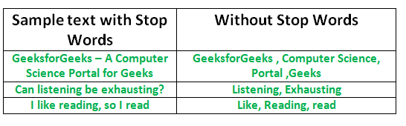
Fig. 3 Stop words Removal [14 ]

3.7 Correlation Analysis:
J. Han in [11] said that frequent pattern mining is required to find recurring relationships in a large transactional or relational data sets. While mining frequent item sets, problem arises when a huge number of item sets are generated satisfying the minimum support threshold. A number of shorter, frequent sub-item sets may be present in a long item set.
C. C. Aggarwal in [12] stated that the words are typically correlated with one another in a large corpus of documents. Number of principal components is much smaller that the feature space. This necessitates to find word correlations. Document frequency is used to filter out irrelevant features. Very infrequent terms contribute the least to the similarity calculations. A term-document matrix may be viewed as in which the (i, j)th entry is the frequency of the jth term in the ith document. Bursty features can be identified depending its underlying frequency. A pair of documents can have a relation if their cosine similarity is above a user-defined threshold. Considering A = (A₁…A_{n}) and B = (B₁...B_{n})) as the normalized frequency term vector in two different documents A and B, the cosine similarity between the two documents can be defined in Equation(i) below

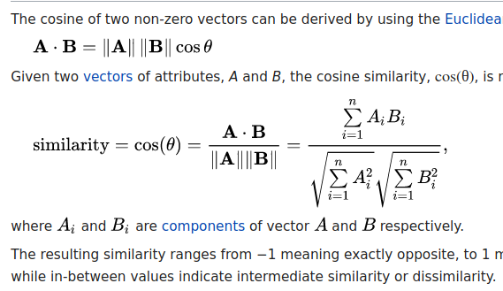

Chapter 4
Methodology
- Tweet extraction and Newspaper data extraction
- Data Preprocessing
- Stop word removal and Tokenization
- POS Tagging
- Selecting nouns, verbs, adjectives, adverbs as tokens
- Computational of sentiment scores(positive,negative)
- Calculation of Positive and Negative Scores per Text
- Normalization of Positive and Negative scores of a Text
- Evaluation of Resultant Score per text
- Indication of sentiment of text
- Generation of Both Scores



News Extracted
Tweet Extracted

Data Pre-processing

Stop word Removal

Tokenization
POS Tagging
Selecting nouns, verbs, adjectives, adverbs as tokens
Computation of sentment scores(positive,negative) from SentiWordNet
Calculate total positive and total negative scores per text

Normalize positive and negative scores

Evaluate resultant score per text

Generation of Both Scores (positive and negative)

Fig. 4 Methodology
4.1 Data Extraction
Tweets of a particular event for a specific time range are collected using the package TwitterWebsiteSearch-master and Newspaper data for day wise from the popular Indian e-newspaper The Telegraph are collected using OCR technology with pytesseract of python and also fetching the particular event using some probabilistic approach with some set of keyword.

4.1.1 Tweet Extraction and Pre-processing
Tweets on a specific event within a certain time period are collected and those containing emoji’s, ‘?’ and non-English characters are removed. The tweet text is produced along with Tweet Id and creation time.
Algorithm : Tweet_Extraction and Pre-processing
Input:
- Set of keyWord of a particular Event
- Time period, Language
Output: Tweet ID, Tweet Created At, Tweet Text
Method:
[1] import the package TwitterWebsiteSearch-master
[2] extract all the tweets for the given event
[3] convert all tweet data into lowercase
[4] remove punctuation, URL ,numbers, emoji from the data
[5] tweet_id=tweet[‘id_str’]
[6]tweet_createdat=tweet[‘created_at’]
[7]tweet_text=tweet[‘text’]
[8]Record tweet_id, tweet_createdat, tweet_text in TweetDetails.txt

4.1.2 News Paper Data Extraction
News on a specific day are collected from e-newspaper portal ,The Telegraph and fetches the particular event using some probabilistic approach with some predefined keyword set of particular event. Before fetches the e-news paper we analysed different day newspapers in the over all time period manually and we set some key word set for particular event and also set some probabilistic threshold value for fetching the news article from e-portal news paper site for a particular event. Suppose we set ten key word for a particular event and also set threshold value 0.6, so if we get six or more than 6 different key word from a news article that we consider our required event article.
Algorithm : Newspaperdata_Extraction and Pre-processing
Input:
- URL of chosen e-newspaper
- Set of predefined keyword of a particular Event
- Time period
- Probabilistic threshold value
Output: News Text
Method:
[1] Import the following packages:
pytesseract, requests, BeautifulSoup, datetime, Image.
[2] Fetches all pages of news in image format
[3] On each article news image for each pages, convert the news in image
to text format.
[4] Check how many key word present in this text.
[5] If the probability value of the number of matched key word is greater
than our given probabilistic threshold value,
then,record the text news as a required event text data.

4.2 Stop Word Removal and Tokenization
In this section, Stop words are removed from Tweet Text and News Text
Algorithm: Stopword_Removal
Input: Tweet Text or News Text
Output: Tweet Text without stop words or News Text without stop word
Method:
[1] Download NLTK
[2] Import stopwords module from nltk
[3] stop_words = set(stopwords.words('english'))
//Consider English stopwords
[4] Tokenize the Text into words
[5] Remove stop words

4.3 POS Tagging
All words (except stop words) in tweet text or news text are assigned with their part of speech
Algorithm: POS Tagging
Input: Text words without Stop Words
Output: Words with their parts of speech
Method:
[1] Download NLTK
[2]Tag each word of a text with its respective part of speech

4.4 Selecting nouns, verbs, adjectives, adverbs as tokens
Here nouns, verbs, adverbs, adjectives present in a tweet are taken into account for sentiment analysis.
Algorithm: Generation of tokens
Input: Words with their pos tagging’s
Output: Nouns, Verbs, Adverbs, Adjectives
Method:
[1] if postag(word)==’NNP’ /‘NNS’/’NN’/’NNPS’ then word=’noun’
[2] if postag(word)==’JJ’/’JJR’/’JJS’ then word=’adjective’
[3] if postag(word)==’RB’/’RBR’/RBS’ then word= ‘adverb’
[4] if postag(word)==’VB’/’VBD’/’VBN’/’VBP’/’VBG’/’VBZ’ then word=
‘verb’
4.5 Calculation of Sentiment Score
Words of a tweet text or news text are matched with the words with hash in SentiWordNet. If pos tagging of the word according to NLTK and SentiWordNet are matched then the positive and negative scores of each word are taken.
Algorithm: Generation of Sentiment Score
Input: SentiWordNet, Words with their pos tagging’s
Output: Positive and Negative Scores of Word(s)
Method:
[1] Check if a word in text is present with hashtag in
SentiWordNet
[2] If the pos tagging’s of the word in SentiWordNet and that according
to NLTK match or not
[3] If match occurs take positive and negative scores for further analysis
4.6 Calculation of Positive and Negative Scores per Text
The positive and negative score of all the words are added to find the Total of Positive and Negative Sentiment Scores (Positive and Negative) with respect to a tweet text or news text.
Algorithm: Generation of Positive and Negative Scores of a tweet
Input: Average Positive and Negative Scores of all Words in a text(tweet or news)
Output: Total of the Positive and Negative Scores of all the words in a text
Method:
[1] For each word in the text
[2] Add Positive Score to Total Positive Score
[3] Add Negative Score to Total Negative Score
[4] End For
4.7 Normalization of Positive and Negative scores of a Text
The positive and negative Sentiment scores of a text are normalized by dividing the total by the number of words in the text.
Algorithm : Average Positive and Negative Score per Text
Input: Positive and Negative Score of text
Output: Average Positive and Negative Sentiment Score of the text
Method:
[1] Count total number of words in text and assign in
word_countintext
[2] Divide both Positive and Negative Score of text by
word_countintext
[3] Assign the results as Average Positive and Negative Sentiment Score

4.8 Evaluation of Resultant Score per text:
The difference between the average of positive and negative sentiments are calculated
Algorithm: Resultant Score per text
Input: Average Positive Sentiment and Average Negative Sentiment of the text
Output: Final_sentiment_value of text
Method:
[1] Subtract from Average Positive Sentiment Score to Average Negative
Sentiment Score to generate Final_sentiment_value

4.9 Indication of sentiment of text
Finding out whether text contain positive / negative sentiment
Algorithm: Ascertain the sentiment polarity of text
Input: Final_sentiment_value
Output: Sentiment Polarity (Positive/Negative)
Method:
[1]if Final_sentimentvalue>0 then Sentiment Polarity = Positive
[2] else
[3] Final_sentiment_value<0 then Sentiment Polarity = Negative

4.10 Generation of weekly sentiment score
Positive/Negative Sentiment Scores of all text are taken for analysis.
Algorithm: Generation of weekly sentiment score
Input: text_createdat, Sentiment score of Tweets per day
Output: Scores of Positive/Negative Tweets or News per Week
Method:
[1] initialization:
positivescore_Week:=0
negativescore_Week:=0
[2]for Month=March to June
for each Week
positivescore_Week+= sentiment_score
negativescore_Week+= sentiment_score
[3] finalpositivescore_Week= positivescore_Week/ 7 ,
[4] finalnegativescore_Week=negativescore_Week/7

Chapter 5
Experimental Configuration
5.1 Dataset
=>Time Range: 24th March 2020 to 30th June 2020
Sl. No. | Tweets and News on event | Key word set
1. | Social Awareness | 'social distancing ', 'quarantine', 'isolation ', 'community spread ', 'lockdown', 'W.H.O guideline', 'guideline', 'awareness ','covid-19 spread', 'Sanitization', 'PPE N95 mask', 'confirmed case', 'prevent', 'stay safe from corona', 'hygiene maintain', 'trauma', 'child affected'
2. | Economic Effect | 'economy effect', 'covid-19 economy', 'lockdown economy', 'industry', 'corporate sector effect ','shutdown economy', 'economic growth', 'companies', 'market', 'jobless in corona time', 'economic fallout', 'manufacturing sector', 'rural agriculture economy', 'RBI', 'unemployment in corona time', 'farmer ','capital investment in corona time', 'atmanirbhar bharat package'
3. | Education | 'Impact of Coronavirus on Education', 'school college off', 'education ', 'lockdown education','covid-19 education', 'school', 'college education', 'examination', 'exam postpone', 'university education ','final year exam', 'education session ', 'lockdown education', 'online education', 'online class ','online child education'
4. | Death | 'covid-19 death', 'corona death', 'co-morbidities death ','death rate in corona'

5.2 TwitterWebsiteSearch-master
Twitter website search master is a package to extract tweets older than 7 days from Twittercom.search without using Twitter API.
Here language of tweet to be extracted and the event whose tweets are extracted are placed in particular commands under this package and the tweets get automatically downloaded for further offline uses.
Tweet attributes such as id_str, created_at and text of a tweet are recorded using TwitterWebsiteSearch-master.

5.3 Pytesseract
Pytesseract is an optical character recognition (OCR) tool for python. That is, it will recognize and “read” the text embedded in images.
Pytesseract is a wrapper for Google’s Tesseract-OCR Engine. It is also useful as a stand-alone invocation script to tesseract, as it can read all image types supported by the Pillow and Leptonica imaging libraries, including jpeg, png, gif, bmp, tiff, and others. Additionally, if used as a script, Pytesseract will print the recognized text instead of writing it to a file.
Google Tesseract OCR Engine is a Machine Learning model developed by Google. Image of characters are trained by Google for this particular model. As we have used scanned article which is basically image of printed data, so it is used as test data for this model and it is acceptable worldwide for its performance and accuracy and for our case it has observed that we have achieved an acceptable accuracy for later work.
5.4 Matplotlib
Matplotlib is an amazing visualization library in Python for 2D plots of arrays. Matplotlib is a multi-platform data visualization library built on NumPy arrays and designed to work with the broader SciPy stack. It was introduced by John Hunter in the year 2002.
One of the greatest benefits of visualization is that it allows us visual access to huge amounts of data in easily digestible visuals. Matplotlib consists of several plots like line, bar, scatter, histogram etc.

5.5 Natural Language Toolkit (NLTK):
NLTK consists of NLP libraries and programs through which various works can be done like tokenisation, postagging, stop word removal and many others.
A sentence or data can be split into words using the method nltk.word_tokenize (sentence).
Words in a sentence can assigned with their parts of speech using nltk.pos_tag(word).
NLTK has a module of stop words to detect stop words from sentences. This can be done using the command
stop_words = set(stopwords.words('english'))
after importing stopwords module of nltk
Sentence | NLTK Tokenization | NLTK POS Tag | NLTK Stopwords
I love to dance | ['I', 'love', 'to', 'dance'] | [('I', 'PRP'), ('love', 'VBP'), ('to', 'TO'), ('dance', 'VB')] | to

5.6 SentiWordNet
SentiWordNet consists of a positive and negative scores against a number of words.
The words whose positive and negative scores are mentioned in a line of SentiWordNet is denoted preceding by a hash.
Positive and Negative Scores are denoted as Pos Score and Neg Score
A word is present for a number of times with it’s positive and negative scores in SentiWordNet. This scores vary depending on the situation when the word is used.
SentiWordNet also assigns scores to words depending on their parts of speech.

Word | POS Score | Neg Score
Able | 0.125 | 0
Haze | 0.125 | 0.25

5.7 CSV(comma-separated values) File
A CSV is a comma-separated values file, which allows data to be saved in a tabular format. CSVs look like a garden-variety spreadsheet but with a . csv extension. CSV files can be used with most any spreadsheet program, such as Microsoft Excel or Google Spreadsheets.
CSV Module implements classes to read and write tabular data in CSV format.
5.8 Hardware Configurations
i. System: hpTM 15-AY542TU
ii. Processor: Intel® Core™ i3-6006U CPU @ 2.00GHz
RAM: 4.00 GB
iii. System type: Ubuntu 16.04, 64-bit Operating System, x64-
based
5.9 Software Requirements
    - Python of version greater than 2.6
    - Integrated Development Environments like Spyder of Python, where Python Programming is done

Chapter 6
Results and Performance Analysis
6.1 Sentiment Score Graph
Sentiment Score graphs are drawn based on the value obtained by dividing sum of all the positive/ negative sentiment scores by the total number of sentiments per Week, on Event Topic basis. There are four topics, and their related graphs are depicted in Figures … below.
i) Public Health Awareness On Tweet Data
Here, In this event take 45,571 tweet from 24th march 2020 to 30th june 2020 day wise on event “Public Health Awareness” from Tweeter and also take Newspaper report from a popular Indian daily News Paper “The Telegraph” , from 24th march 2020 to 30th June 2020 day wise to analysis the public sentiment.
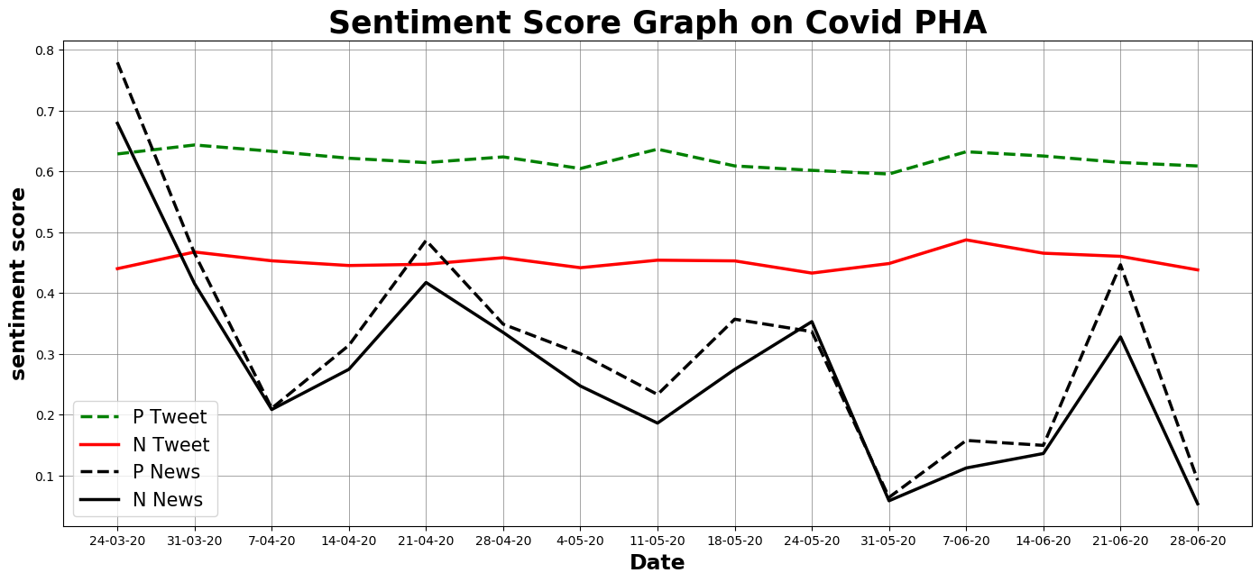

Fig.5.: Sentiment Scores on Public Health Awareness
Fig 5 apparently shows that the positive sentiment score is more than the negative sentiment score in the time period of 24th March 2020 to 30th June 2020 for both data source. Interestingly, there is always more positive score than negative score throughout the time period, which possibly indicates the common people of India are well aware of the corona virus in this pandemic time.
On the other hand, it also reflects that both score are equivalent for newspaper data on 7th April and 24th May to 31st May. Very understandably, in this graph graph from two different data source(Tweet and Newspaper data) represent almost same result throughout time period.
A large no of people in india who belong to backward classes so ,only from tweeter report ,the common people’s sentiment can not be found on this event ,newspaper reports reveal the actual image of society.In this graph the positive score graph is almost close to the negative sentiment graph on newspaper report , It is understood that for some reason, the reaction of people to the negative awareness is quite good. For example ,some of Indian news media have reported several cases where people have fled hospitals while waiting to be tested for COVID-19. Such cases need to be thoroughly analysed and the communication gaps identified, Women in all Indian households do not have equal access to health workers to report their symptoms or get the necessary medical care, It has also been seen in various newspapers that some common people went out ignoring the lockdown without using proper mask and not proper maintaining social distancing and most of the day labour were out in the rush of their work ignoring the lockdown, almost from the end of the third lockdown fetch.
ii) Economic effect
Here, In this event take 32,478 tweet from 24th march 2020 to 30th June 2020 day wise on event “Economic Effect” from Tweeter and also take Newspaper from a popular Indian daily News Paper “The Telegraph” , from 24th march 2020 to 30th June 2020 day wise to analysis the public sentiment.
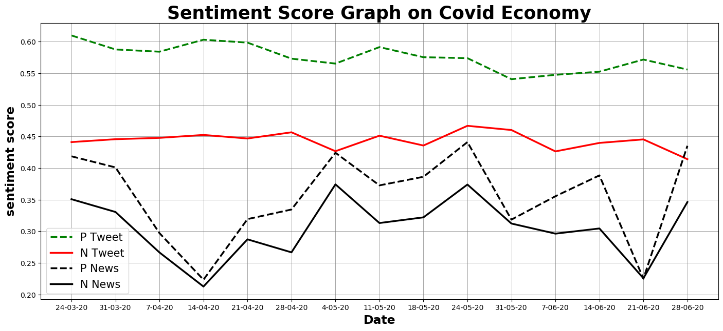

Fig.6: Sentiment Scores on Economic effect

Fig 6 apparently shows that the positive sentiment score is more than the negative sentiment score in the time period of 24th March 2020 to 30th June 2020. Interestingly, there is always more positive score than negative score throughout the time period, which possibly indicates this graph shows that the people of India are taking the Indian Economy positively in this time for tweet aspect.
The graph plot of Economic Event on Newspaper data show an overall marginal supremacy of Positive sentiment, with slight reversals between May 31 and June 21 according to newspaper data. But there is a gradually come down positive score after March 31 in the beginning of first lockdown period and then gradually increase the positive score from the second lockdown fetch! And also see the score increases from the declaration of “AtmaNirvarBharat” package on May 12, this continue up to May 24 and then slight ups and downs with a negative hike up to June 30.
It is understood by looking at this graph ,despite the lockdown affected the economy, the economic condition did not fall out at all, that could be big reason ,despite the lockdown there was no shortage of raw money supply, food supply, medicine supply etc to the people. This graph also indicate that economic affect not only dependent by GDP rate, because it has been observed that since the beginning of the lockdown ,the GDP growth rate has been steadily declining. This graph also shows that there have been economic fallouts at several points, which may be reason various manufacturing industries are shut down, people are laid off, so many migrant workers return home from their work place etc.
iii) Covid-19 Death
Here, In this event take 7,309 tweet from 24th march 2020 to 30th June 2020 day wise on event “Economic Effect” from Tweeter and also take Newspaper from a popular Indian daily News Paper “The Telegraph” , from 24th march 2020 to 30th June 2020 day wise to analysis the public sentiment.

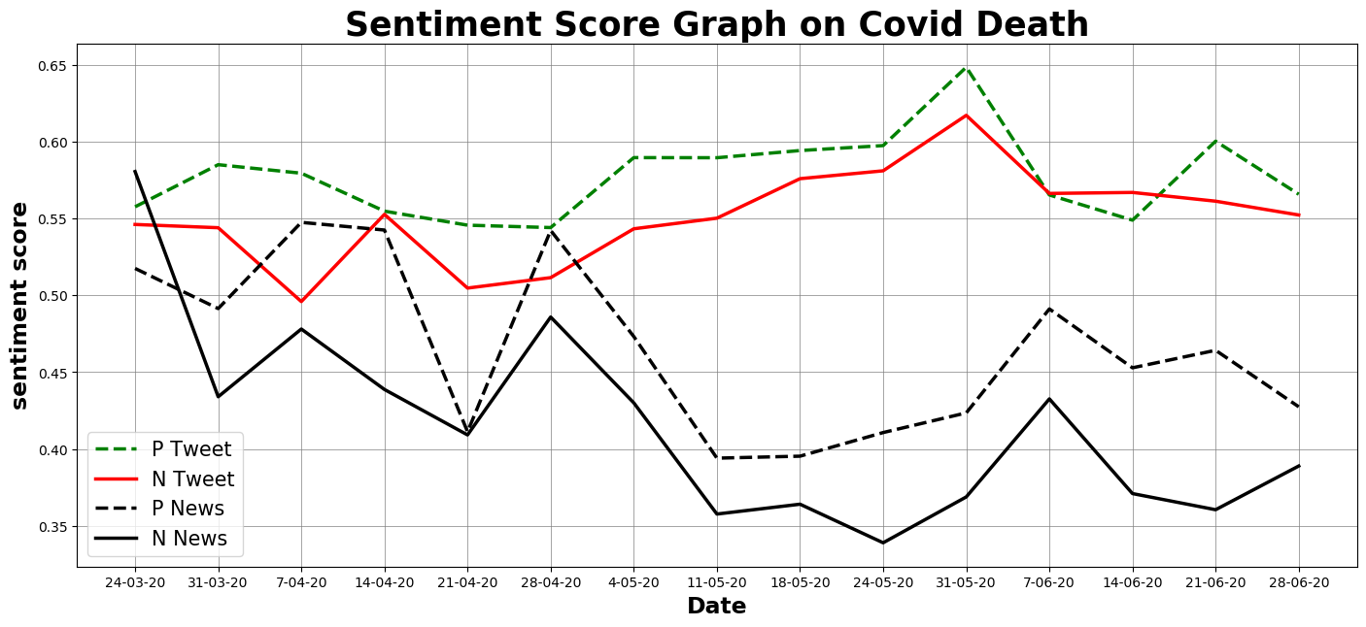
Fig.7: Sentiment Scores on Covid-19 Death Event
Fig 7 apparently shows that the positive sentiment score is more than the negative sentiment score almost throughout the time period of 24th November 2020 to 30th June 2020 for the tweeter data. Significantly, at some point the negative score is more than the positive score, this may be due to the effect of a human panic on the covid-19 situation at this time.
This graph, on the other hand, shows an initial high spike of negative sentiment when First lock down started according to news data. Very understandably, the repercussion of the incident was felt most strongly at the beginning. The graph also reflects that Positive score exceed Negative score throughout the whole time period and with slight reversals on April 21.

iv) Covid-19 Education
Here, In this event take 16511 tweet from 24th march 2020 to 30th June 2020 day wise and also take Newspaper from a popular Indian daily News Paper “The Telegraph” , from 24th march 2020 to 30th June 2020 day wise to analysis the public sentiment
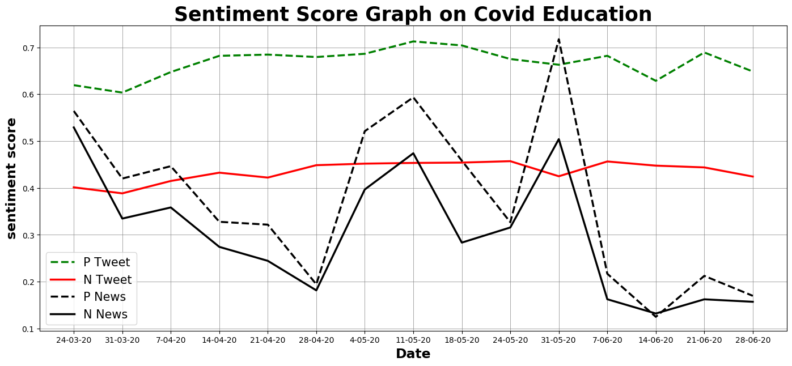
Fig. 8: Sentiment Scores on Covid-19 Education Event

Fig 8.1 apparently shows that the positive sentiment score is more than the negative sentiment score in the time period of 24th March 2020 to 30th June 2020 for tweet data. Interestingly, there is always more positive score than negative score throughout the time period, which possibly indicates this graph shows that the people of India are taking the Indian Online Education positively for this time.

The figure also apparently shows that the positive sentiment score is more than the negative sentiment score almost throughout the time period of 24th November 2020 to 30th June 2020 according to news data. Significantly, at some point the negative score is equivalent to the positive score, this may be due to the effect of poor student, those who could not accept the online education system for lack of smart device at this time.

6.2 Cosine Similarities:
Sl. No. | Documents | Cosine Similarity (rounded to two decimal places)
1 | Tweeter Data and Newspaper Data on Public Health Awareness | 0.64
2 | Tweeter Data and Newspaper Data on Economic Effect | 0.92
3 | Tweeter Data and Newspaper Data on Death | 0.89
4 | Tweeter Data and Newspaper Data on Education | 0.70

All the cosine similarity scores (calculated using Eq.(i)) are greater and equal to than 0.5. So the tweet scores and counts of all the events can be combined to give an overall statistics as depicted in the following figure.

6.3. Overall sentiment score bar graph
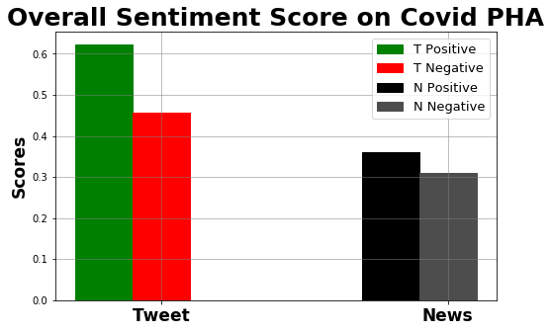

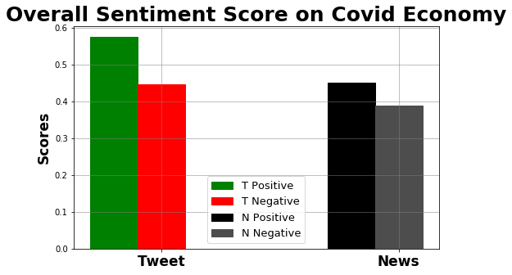

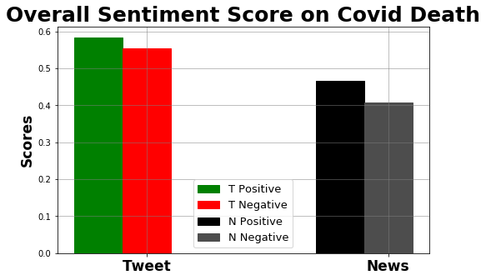

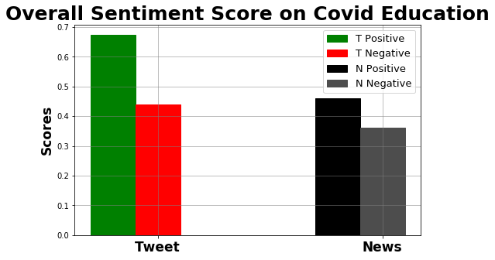
The combined sentiment score from both data source reflects a majority towards positive polarity. Although the positive polarity of all the events is high, we also see the predominance of negative polarity in some of the events such as Covid Economy and Covid Death.
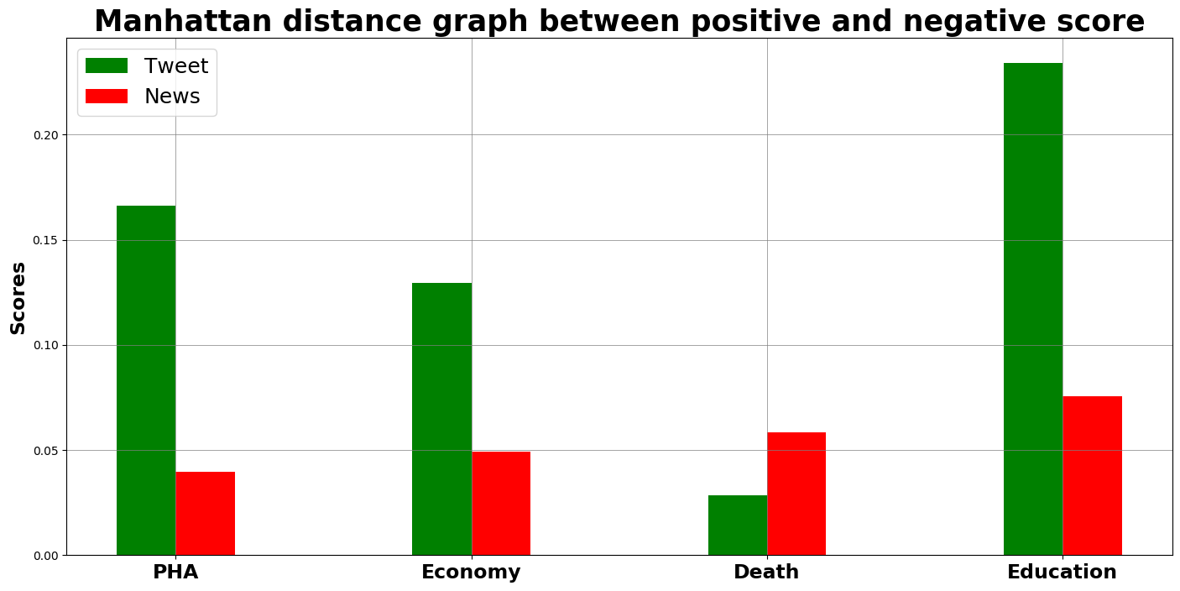

Chapter 7
Conclusion and Future Scope
As seen, sentiment analysis enables one to understand public sentiments with respect to specific products/services by their Comments, feedback, public opinion, newspaper report etc. and hence can be used for better decision-making approach. As discussed, we can see from our survey that we get from tweet data 51.25% ,56.34%, 60.52%, 57.69% positive score and 48.74%, 43.65%, 39.47%, 42.30% negative score and from newspaper data 53.35%, 53.76%, 55.92%, 53.81% positive score and 46.64%, 46.23%, 44.07%, 46.18% negative score correspondingly the events covid-death, covid-economy, covid education and covid-public health awareness . So, from the overall analysis for all event, we can see that positive impact is more than negative impact but their difference is not too much. Overall, it can be seen that Indians have taken the fight against COVID19 positively, Nevertheless, as of now, the lockdown response seems positive and indicates that India has succeeded in controlling the corona virus spread to a great extent as a result ,the positive effect of all our events have been higher.

Future studies can look in to pre and post lockdown tweets and understand whether there was a change in sentiments from the beginning to the end of the lockdown. Also, future studies can look in to factors that affect mental health during lockdowns and pandemic spreads. Another area for future research could be tackling of fake news that gets circulated through social media, impacting the mental health of the receivers.
The approach described in this thesis is therefore only reliably usable within
the constraints of the corpus we have collected. In future work, we propose an
improved system for sentiment prediction based on the lessons learned during the work on this thesis. Due to time constraint, the research has been restricted to a sample, but in future, people could use Twitter sentiment analysis in real time to predict the emoji sentiment which are used the most in social media currently in there post frequently, which will also improve the accuracy of prediction. Even researchers can identify new ways of classifying the textual data into various moods such as happiness, alertness, certainty, and calmness. In this research, Twitter is the only social media taken into account, but various platforms such as, Stock Twits, Yahoo Finance, Facebook, blogs, discussion forums can also be analysed. Here we also use newspaper article only English language daily paper ,in future if we use different regional language newspaper and if we translate those article in English language and then find the sentiment of those article then we get more accurate result.
The research work presented in this thesis has identified new directions for future research. In this work, the eight different numerical datasets are used from Learning Repository. Further, the research work may be extended and analysed with categorical datasets. This can be extended by evaluation criterion measures for finding the relevant features and for improving the accuracy of prediction.

8. Reference
[1] Tanu Singhal, “A Review of Coronavirus Disease-2019 (COVID-19)”,2020
[2] Gopalkrishna Barkur,Vibha,Giridhar B. Kamath. “Sentiment analysis of
nationwide lockdown due to COVID 19 outbreak: Evidence from
India”,2020
[3] Christiana Loana Muntean, Gabriela Andreea Morar, Darie Moldovan:
Exploring the Meaning behind Twitter Hashtags through Clustering. Business
Information Systems Workshop
[4] Hidenao Abe: Extracting User Behavior-related Words and Phrases using
Temporal Patterns of Sequential Patterns Evaluation Indices. Vietnam J
Comput Sci, 2017
[5] Zhao Jianqiang, Gui Xiaolin: Comparison Research on Text Pre-Processing
Methods on Twitter Sentiment Analysis. Supported by: NSFC under Grant
1472316(in part), Shaanxi Science and Technology Plan Project under Grants
2016ZDJC-05 and 2013ZS16 -Z01/P01/K01 (in part) and Fundamental
Research Funds for Ministry of Education of China under Grant XKJC2014008,
February,2017.
[6] Pang B. and Lee L. Opinion Mining and Sentiment Analysis. Journal
Foundation and Trends in Information Retrieval. 2008; 2(1-2): 1 – 135
[7] A Pappu Rajan and S.P.Victor, “ Web Sentiment Analysis for
Scoring Positive or Negative Words using TweeterData”, International
Journal of Computer Applications (0975 – 8887) Volume
96– No.6, June 2014
[8] Shailendra Kumar Singh and Sanchita Paul , “Sentiment Analysis of Social
Issues and Sentiment Score Calculation of Negative Prefixes”, International
Journal of Applied Engineering Research · June 2015
[9] Anusha K S , Radhika A D, “A Survey on Analysis of Twitter Opinion Mining
Using Sentiment Analysis”, International Research Journal of Engineering
and Technology (IRJET)
[10] http://www.expertsystem.com/machine-learning-definition/
[11] J. Han, M. Kamber, J. Pei, “Data Mining: Concepts and Techniques”, 3rd
Edition, Morgan Kaufmann Publishers, An imprint of Elsevier, © 2012
[12] C. C. Aggarwal, C. X.Zhai, “Mining Text Data”, Springer, 2012
[13] Shiv Kumar Goel,Sanchita Patil, “Twitter Sentiment Analysis of
Demonetization on Citizens of INDIA using R”,2017
[14] https://www.geeksforgeeks.org/removing-stop-words-nltk-python/

